Mini-economy unit: Saving for Wants and Needs: The Hard-Times Jar
Saving for the Hard Times
This lesson introduces the concept of saving with The Hard Times Jar, by Ethel Footman Smothers, in which a family of migrant workers makes tough decisions about when to spend and when to save. The lesson uses the book as a “hook,” or a springboard to a variety of activities that use economic thinking in which students analyze the decisions that migrant works face, and ultimately analyze their own personal decisions regarding delayed gratification. In the culminating activity, students use surveys and classroom deliberation to decide what should go into their class’s own Hard Times Jar.
Questions for inquiry
Compelling question: “When should you save—and when should you spend?”
Developing supporting questions:
- “What is saving?”
- Students will read The Hard Times Jar and determine how money is saved and what it is saved for. (Activity #1)
- Students decide what they would use their savings for if they collected their own money in a Hard Times Jar. (Hard Times Jar Activity #2)
Economic concepts
- Comparing the life of migrant workers in the book and primary source pictures of migrant workers (Activity#3)
- What is the opportunity cost of making one choice over the other? (When we have to make a choice- Activity#4)
- Is it a natural, capital or human resource? (Seek and Find using the pictures in the book Activity #5)
- How safe is your money? Where do we store money? (Activity #6)
Using evidence and sources
- Link to a YouTube reading of The Hard Times Jar here: https://www.youtube.com/watch?v=pbyoh8X4hOw
- How do we save our money? (Activity #6)
- What is a safe place to keep our savings? (Activity #6)
- Comparing the life of migrant worker and how they save (Activity #5)
- Conduct research and decide how to use class savings. Analyze data to make decisions. (Activity #6)
Communicating conclusions and taking informed action
- Students conduct a survey to determine the best way to use their savings. (Activity #7)
- Students create a presentation to inform others about their donation/buying suggestion. (Activity #7)
- “Save or Spend” activity from the Mini-Economy Business Plan website, in which students keep track of when they saved and when the spent. They also weigh the opportunity costs of their choices.

Vocabulary:
Natural Resources
Capital Resources
Human Resources
Scarcity
Economic Choice
Savings
Producing
Consuming

Virginia SOLs for History and Social Studies:
3.9 The student will identify examples of making an economic choice and will explain the idea of opportunity cost (what is given up when making a choice).
2.7 The student will describe natural resources (water, soil, wood, and coal), human resources (people at work), and capital resources (machines, tools, and buildings).
2.9 The student will explain that scarcity (limited resources) requires people to make choices about producing and consuming goods and services.
1.8 The student will explain that people make choices because they cannot have everything they want.
1.9 The student will recognize that people save money for the future to purchase goods and services

Activity 1:
Rubric Line Item: Savings
Discussion: In The Hard Times Jar, Emma and her family are migrant workers and money is tight. Emma dreams of owning store bought books, but for now she must write her own stories. Emma has a plan to save all of the money that she earns from picking apples on the farm in Mama’s hard-times jar. With the extra money, Emma will be able to convince Mama to make purchases for extra wants, like store bought books. Emma’s plan is changed when she has the opportunity to attend school for the 1st time. She must now make an economic decision. If she attends school during the day, she will not be able to save money in the Hard Times Jar.
Students will listen to the book The Hard Times Jar and participate in a discussion about what life would be like as a migrant worker and making decisions about saving and spending.
Materials: Book The Hard Times Jar, by Ethel Footman Smothers (ISBN# 978-0-374-32852-8)
Activities for use with the Hard Times Jar:

Procedure:
- Read students the book The Hard Times Jar. Ask students to think about what life would be like as a migrant worker.
- What kind of a house did Emma and her family live in?
- Is her house like one that you might live in today?
- What kind of chores was Emma responsible for?
- How did Emma’s chores compare with the chores that you have to do?
- How did Emma earn money?
- What did Emma do with the money that she earned?
- What was Emma’s family saving money for?
- What do you think Emma did with the 6 shiny quarters that her mother gave her?
- Would you like to live the way that Emma lived? What would you miss the most? How would your life be different? What economic decisions would you have to make?

Activity 2: Sometimes money is scarce. We do not have enough to buy all of our wants and needs. Sometimes we have to use our Hard Times Jars to buy needs instead of wants.
Is it necessary for everyone to have a Hard Times Jar?
Do we have Hard Times Jars today?
What is another name for a Hard Times Jar?
Why is saving important?
What are some reasons that families need to save money?

You have just filled your Hard Times Jar with coins. It has taken you over a year of hard work to fill the jar to the top. What would you now do with your money?

_____________________________________________________________________________________
_____________________________________________________________________________________
_____________________________________________________________________________________
_____________________________________________________________________________________
_____________________________________________________________________________________
_____________________________________________________________________________________
_____________________________________________________________________________________
_____________________________________________________________________________________
_____________________________________________________________________________________
_____________________________________________________________________________________
Activity 3:

Texas tenant farmer in Marysville, California, migrant camp during the peach season
- Digital ID: (b&w film copy neg. of pint) cph 3a00973 http://hdl.loc.gov/loc.pnp/cph.3a00973
- Reproduction Number: LC-USZ6-1026
Repository: Library of Congress Prints and Photographs Division Washington, DC 20540 USA http://hdl.loc.gov/loc.pnp/pp.print
These photographs appears in the Library of Congress, and were probably taken by the US Government to see what work was like for migrant workers during the Great Depression.

Its title is "Texas tenant farmer in Marysville, California, migrant camp during the peach season.

1927 made seven thousand dollars in cotton.

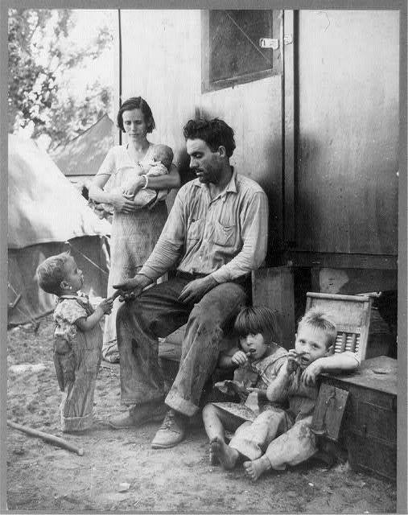
1928 broke even.

1929 went in the hole.

1930 still deeper.

1931 lost everything.

1932 hit the road.

1935, fruit tramp in California.”

Describe details of what you see in the picture.

If they had a hard times jar, what might they use their savings for?
What do you think the father is saying to his son?
Is this picture helpful for knowing this family’s situation? What other information would be helpful for answering these questions?

What clues helped you make your decisions?

Look at this photo and answer the questions.
How do these workers appear to be different from the ones in the picture above?
What sort of choices may these workers face?
If they had a Hard Times Jar, what might they use it for?
Is this picture helpful for knowing these peoples’ situation? What other information would be helpful for answering these questions?

Migrant workers eating dinner by the side of their car while they are camped near Prague, Oklahoma. Lincoln County
- Digital ID: (intermediary roll film) fsa 8b22008 http://hdl.loc.gov/loc.pnp/fsa.8b22008
- Reproduction Number: LC-USF34-033380-D (b&w film neg.)
- Repository: Library of Congress Prints & Photographs Division Washington, DC 20540 http://hdl.loc.gov/loc.pnp/pp.print
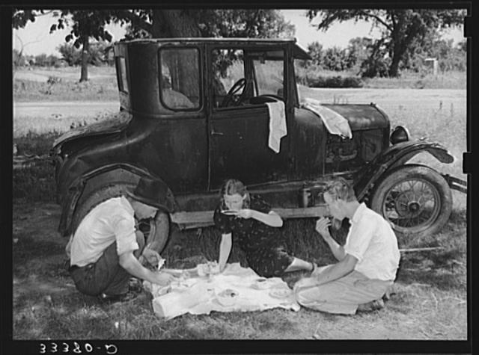

Activity 4: When We Have to Make a Choice
Overview:
Students will evaluate choices made by Emma by considering the pros and cons of her decisions. Use the Decision Scale to help you make your decisions.
Rubric Line Item: Economic Choice/Opportunity Cost
Materials:
Emma’s Decision Cards for each group of students
Decision Scale for each group of students
Procedure:
- Explain to the students that when we make decisions, we consider the good and bad points of a choice. As good decision makers, we make decisions, when there are more good points than bad.
- Emma had to make choices in her young life that were often very difficult. Put yourself in Emma’s position and consider the choices that she had to make.
- Give each group of students a set of decision cards and have them identify the economic problem in the scenario. Record the problem in the box on the top of the scale.
- Have the students write good and bad choices that they have about the problem.
- In the end, have the students use the points to make an economic decision.
- Students may share their decisions and good points with the rest of their classmates.

Decision 1: Emma has a choice. She can watch her little brother and sister while her mother works in the field or she can read the stories that she has written. | Decision 2:  Emma has a choice. She can take the store- bought books from the school room or she can use the money from the Hard Times Jar to buy one of her own. | Decision 3:  Emma has a choice. She can use her extra time to do chores for extra money for the jar or she can use the extra time to practice her reading.
Decision 4:  Emma has a decision. She can go the school and learn with the other children or she can stay with her family and earn money for the Hard Times jar. | Decision 5:  Emma has a choice. She can work in the fields picking apples and earn money for her family or she can hide in the fields and write in her storybook. | Decision 6:  Emma has a choice. She was given 6 shiny quarters by her mother. She can spend the money on a store bought book or she can put the money back in the jar for family needs.

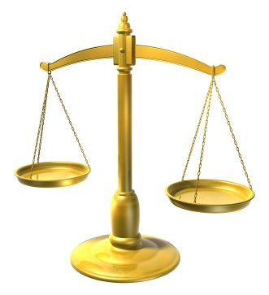
Decision Scale
Choice 2

Choice 1

The Economic Problem
Place your choice card here

And the decision is…

Activity 5:
Practice: Natural/Capital/ Human Resources
Take a look at the pictures of Emma’s family at work from The Hard Times Jar. What natural, capital, and human resources do you see?
Human Resources
Capital Resources
Natural Resources

Activity 6: How safe is your money?
Discussion: Emma’s mother saved her money in a glass jar. Was this safe?
Where do you keep your money? Is that safe?
Where are some places that people keep their money to be safe?
Materials:
Saving Cards
Good Choice/Bad Choice Cards
Procedure:
- Place Good Choice Card on one side of the classroom. Place Bad Choices Card on the opposite side of the classroom.
- Show the students a saving card. Have the students make a choice about the saving card. Is it a Good Choice or a Bad Choice? Would you feel safe keeping your money in that place?
- Have students move to the side of the classroom that matches their choice. While there, have students discuss their reasoning with their peers.
- Ask students to explain their choices. Ask if anyone would like to make a change based on the discussion.

SAVINGS CARDS
Bank | Glass Jar
Pocket | Backpack  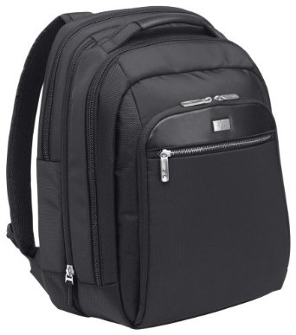
Under the mattress  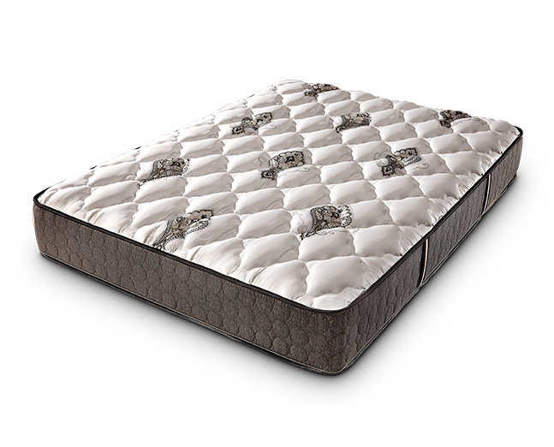 | Piggy bank
Wallet | Safe  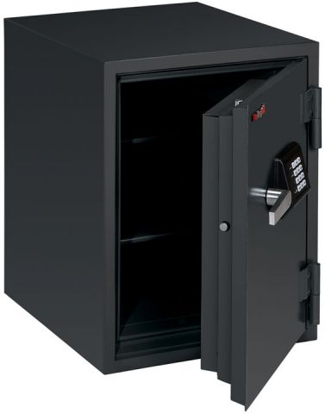
Plastic Baggie | Freezer  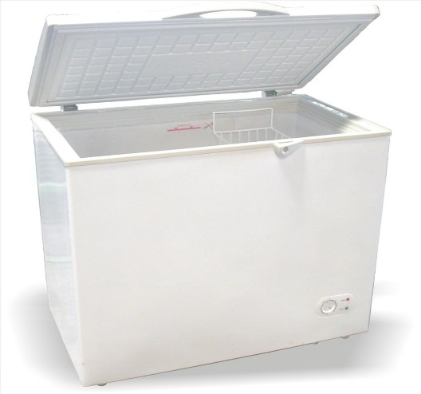

Activity# 7: Action Plan-What do we do with our saving?
Discussion: Emma’s mother kept her savings jar for things that were needed during hard times.
If the class were to save pennies for 1 year, what could we do with them?
How much money do you think that we could save?
How could we make that decision?
Where would you store our money?
Have student brainstorm ideas for things that they could buy for the classroom, support a local or national fund, donate money to a special need.
Narrow the ideas down to several ideas. Have the students conduct a survey to determine the final two. Have the students divide into teams to create a plan to present to the other team. The plan must contain how the item or donation will benefit the class or organization. The presentation must be limited to 5 minutes.
After the presentation, students will make a decision using the decision scale to justify their reasons for selection.

