Ancient Civilizations

Resource Review Relay Race

**Introduction**: This lesson reviews productive resources as well as the cultures of Greece, Rome and Mali. It can be used as a quick introduction or a culminating activity. Either way, the students should enjoy the competitive nature of the activity. Would this also be a good time to discuss Greece’s contribution of the Olympics?

**Concepts**:

* **Natural Resources** – gifts from nature, such as land, water and trees
* **Human Resources**- human effort directed toward producing goods and services (labor)
* **Capital Resources** – good produced and used to make other goods and service (tools)

**Objectives**:

* The student will review the terms natural resources, human resources, and capital resources
* The student will review aspects of ancient civilization
* The student will participate in a class problem solving activity
* The student will give examples of natural resources, human resources, and capital resources

**Virginia SOL**

***NEW*** 3.7

The student will explain how producers in ancient Greece, Rome, and the West African empire of Mali used natural resources, human resources, and capital resources in the production of goods and services

**Time Required**: 25-30 minutes

**Materials**:

* Three sets of puzzle cards copied on card stock (for ease of organization use a different color for each set)
* Visual – Egyptian Farmer Puzzle
* Writing tools
* Ziploc Bags
* Optional- A copy of “Make Your Own Puzzle” for each student

**Procedure**:

1. Prepare material prior to class.
2. Introduce the lesson by telling the students that after a brief review they will be participating in a competitive class activity.
3. Review the concepts of natural resources, human resources, and capital resources.
4. Explain to the students that they will be putting this knowledge to work by assembling three puzzles.
5. Display the Egyptian Farmer and review its contents. Tell the students that there are three puzzles in each bag. Explain that each team is to assemble these puzzles on the predetermined flat surface.
6. Divide the class into three teams. (Two teams will work for smaller classes.)
7. Give each team a Ziploc bag with a complete puzzle set.
8. Instruct the teams that one student from each team is to take the bag to the flat surface, remove a piece and try to place it correctly. (This should become easier as the relay progresses.) That student then returns, giving the bag to the next person in line, who then repeats the same procedure until all three puzzles are completed.
9. The winning team gets bragging rights.
10. Review the content on the puzzle pieces, discussing the three cultures represented as well as the economic concepts involved.

Extension Activity: Students may create their own puzzle pieces using the puzzle pattern.

#1 *Greek Potter*

[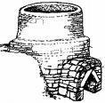](http://www.ceramicstudies.me.uk/hgrafs03/cretan_kilns_dia1as.gif) MCj03584310000%5b1%5d

Pottery Firing Kiln Clay

MCj02510460000%5b1%5d

Greek Potter

#2: Mali Basket Weaver

[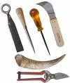](http://images.google.com/imgres?imgurl=http://www.englishwillowbaskets.co.uk/images/tools_cover.jpg&imgrefurl=http://www.englishwillowbaskets.co.uk/tools.htm&usg=__MMHh9as32exJy3fhPVdYfStDhpA=&h=324&w=275&sz=14&hl=en&start=1&tbnid=oJHy8mOhi6a7ZM:&tbnh=118&tbnw=100&prev=/images%3Fq%3Dbasket%2Bmaking%2Btools%26gbv%3D2%26hl%3Den%26sa%3DG)MCNA00134_0000[1]

Basket Making Tools Reeds

*MCPE04115_0000[1]*

Mali Basket Weaver

#3: Roman Merchant

MCj02153540000[1] MCj02644800000[1]

Food Scales Fruit

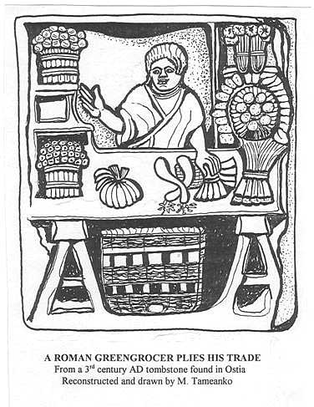

Roman Merchant

# 4 Egyptian Farmer

MCj04124640000[1] 

Sun Shovel

[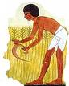](http://images.google.com/imgres?imgurl=http://www.woodlands-junior.kent.sch.uk/Homework/egypt/images/sickle.jpg&imgrefurl=http://www.woodlands-junior.kent.sch.uk/Homework/egypt/farming.htm&h=219&w=177&sz=15&hl=en&start=18&um=1&usg=__hXqT4_3ItJamtVzvRMCuxYgqarg=&tbnid=-auyeaLeRpeumM:&tbnh=107&tbnw=86&prev=/images%3Fq%3DAncient%2BEgypt%2Bhoe%26um%3D1%26hl%3Den%26rlz%3D1T4RNWN_enUS229US240%26sa%3DG)

Egyptian Farmer

Create Your OwnPuzzle

Ancient Civilizations

Some character suggestions:

Human Resources Suggestions: Greek Ship Builder, Roman Road Builder, Mali Miner

Natural Resource Capital Resource

Human Resource